🧩 1. What is Algorithm Complexity?
When you write a program (or algorithm), two main questions arise:
- How fast is it? → ⏱️ Time Complexity
- How much memory does it use? → 💾 Space Complexity
These are collectively called Algorithm Complexities — they help us compare different algorithms and choose the best one for a problem.

⚙️ 2. TIME COMPLEXITY
👉 Definition:
Time Complexity measures how the running time of an algorithm increases with the input size (n).
It is not about exact time in seconds, but rather how the number of operations grows as n increases.

🧠 Example 1: Constant Time – O(1)
def get_first_element(arr):
return arr[0]
✅ This function always takes 1 step, no matter how large the array is.
👉 Time Complexity = O(1)
Input Size (n) | Operations | Big-O
10 | 1 | O(1)
1000 | 1 | O(1)

🧠 Example 2: Linear Time – O(n)
def print_elements(arr):
for item in arr:
print(item)
Here, time increases linearly with array size.
Input Size (n) | Operations | Big-O
10 | 10 | O(n)
1000 | 1000 | O(n)
👉 Time Complexity = O(n)

🧠 Example 3: Quadratic Time – O(n²)
def print_pairs(arr):
for i in arr:
for j in arr:
print(i, j)
Each element pairs with all others → n × n = n² operations.
Input Size (n) | Operations | Big-O
10 | 100 | O(n²)
1000 | 1,000,000 | O(n²)
👉 Used in: Nested loops like Bubble Sort, Insertion Sort.

🧠 Example 4: Logarithmic Time – O(log n)
def binary_search(arr, target):
low, high = 0, len(arr) - 1
while low <= high:
mid = (low + high) // 2
if arr[mid] == target:
return mid
elif arr[mid] < target:
low = mid + 1
else:
high = mid - 1
return -1
Each step cuts the data in half → log₂(n) steps.
Input Size (n) | Operations | Big-O
8 | 3 | O(log n)
16 | 4 | O(log n)
👉 Used in: Binary Search, Balanced Trees, Divide & Conquer Algorithms.

🧠 Example 5: Exponential Time – O(2ⁿ)
def fibonacci(n):
if n <= 1:
return n
return fibonacci(n-1) + fibonacci(n-2)
Each call spawns two more → total ≈ 2ⁿ calls.
🚨 Extremely inefficient for large n.
n | Operations | Big-O
5 | 32 | O(2ⁿ)
10 | 1024 | O(2ⁿ)
👉 Used in: Recursive problems without memoization (like brute-force subset generation).

📊 3. Common Time Complexities
Complexity | Name | Example
O(1) | Constant | Accessing element by index
O(log n) | Logarithmic | Binary search
O(n) | Linear | Traversing array
O(n log n) | Linearithmic | Merge sort, Quick sort
O(n²) | Quadratic | Nested loops
O(2ⁿ) | Exponential | Recursive Fibonacci
O(n!) | Factorial | Generating permutations

💾 4. SPACE COMPLEXITY
👉 Definition:
Space Complexity measures the total memory required by the algorithm, including:
- Input space
- Auxiliary space (temporary variables, recursion stack, etc.)

🧠 Example 1: O(1) Space
def sum_array(arr):
total = 0
for num in arr:
total += num
return total
Only total variable used → constant memory.
👉 Space Complexity = O(1)

🧠 Example 2: O(n) Space
def copy_array(arr):
new_arr = []
for num in arr:
new_arr.append(num)
return new_arr
A new array of size n created →
👉 Space Complexity = O(n)

🧠 Example 3: Recursion Space
Each recursive call adds to the call stack.
def factorial(n):
if n == 1:
return 1
return n * factorial(n-1)
Here, there are n calls → Space Complexity = O(n) (due to recursion stack).

⚖️ 5. Relation Between Time and Space
Often, optimizing for time increases space (and vice versa):
Algorithm | Time | Space
Recursive Fibonacci | O(2ⁿ) | O(n)
DP Fibonacci | O(n) | O(n)
Iterative Fibonacci | O(n) | O(1)
👉 Trade-off: Sometimes you store extra data (using space) to compute faster.

🧩 6. Real-Life Analogy
Situation | Time Complexity | Space Complexity
Finding a name in phone book (Binary Search) | O(log n) | O(1)
Finding a name in random list | O(n) | O(1)
Memorizing results to avoid rework (Dynamic Programming) | ↓ Time | ↑ Space

🔍 7. Big-O, Big-Ω, and Big-Θ Notations
Notation | Meaning | Example
O(f(n)) | Worst case (upper bound) | Bubble sort → O(n²)
Ω(f(n)) | Best case (lower bound) | Bubble sort → Ω(n)
Θ(f(n)) | Average case (tight bound) | Merge sort → Θ(n log n)

🚀 8. Practical Interview Tip
When analyzing an algorithm:
- Count loops → gives time growth.
- Count extra data structures → gives space growth.
- Use asymptotic notation (ignore constants & small terms).
Example:
for i in range(n): # O(n)
for j in range(5): # O(5) -> O(1)
print(i, j)
Total = n × 1 = O(n) ✅

🧮 9. Summary Table
Type | Example | Time | Space
Constant | Access element | O(1) | O(1)
Linear | Traverse array | O(n) | O(1)
Quadratic | Nested loop | O(n²) | O(1)
Logarithmic | Binary Search | O(log n) | O(1)
Exponential | Recursive Fibonacci | O(2ⁿ) | O(n)

✅ 10. Key Takeaways
- Time Complexity → How fast the algorithm runs.
- Space Complexity → How much memory it uses.
- Always think in terms of input size (n).
- Use Big-O Notation to express scalability.
- Optimize for balance — fast enough and memory efficient.

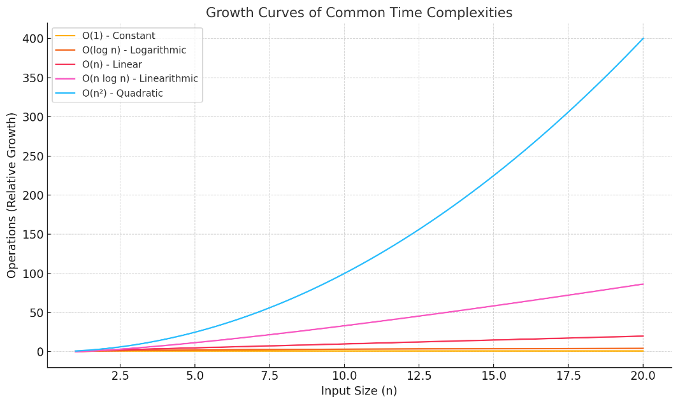
Here’s the visual comparison 👆 showing how different time complexities grow as input size increases:
- 🟩 O(1) stays flat (constant time)
- 🟦 O(log n) grows very slowly
- 🟧 O(n) increases linearly
- 🟪 O(n log n) grows moderately
- 🔴 O(n²) grows rapidly
This helps you visually understand why algorithms with O(log n) or O(n) are far more efficient for large inputs than O(n²) or higher.
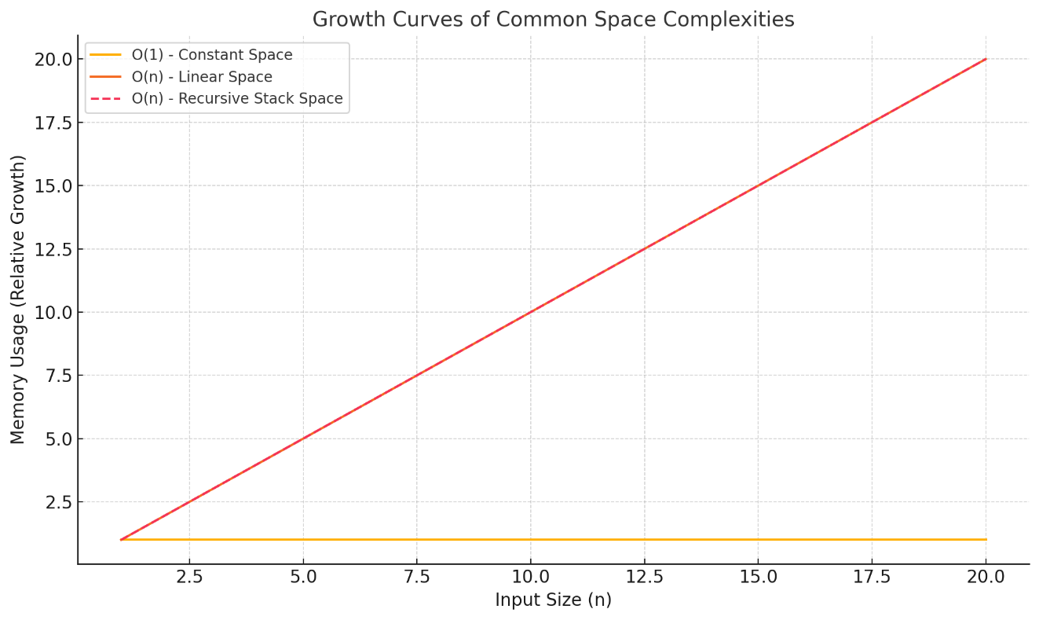
Here’s the visual chart 👆 showing space complexity growth:
- 🟩 O(1) → Constant memory (e.g., single variable).
- 🟦 O(n) → Linear memory (e.g., array copy, dynamic programming).
- 🟪 O(n) (dashed line) → Recursive stack memory usage.
This helps you see that algorithms with recursion or additional data storage grow linearly in memory use — while constant-space algorithms remain efficient.

